SEC Form 4
FORM 4 |  | UNITED STATES SECURITIES AND EXCHANGE COMMISSION  Washington, D.C. 20549  STATEMENT OF CHANGES IN BENEFICIAL OWNERSHIP  Filed pursuant to Section 16(a) of the Securities Exchange Act of 1934  or Section 30(h) of the Investment Company Act of 1940
  OMB APPROVAL
  OMB Number: | 3235-0287
  Estimated average burden
  hours per response: | 0.5
 | Check this box if no longer subject to Section 16. Form 4 or Form 5 obligations may continue. See Instruction 1(b).
 | Check this box to indicate that a transaction was made pursuant to a contract, instruction or written plan for the purchase or sale of equity securities of the issuer that is intended to satisfy the affirmative defense conditions of Rule 10b5-1(c). See Instruction 10.
1. Name and Address of Reporting Person*  (Street) | 2. Issuer Name and Ticker or Trading Symbol  INCYTE CORP [ INCY ]  Foreign Trading Symbol | 5. Relationship of Reporting Person(s) to Issuer  (Check all applicable)
  Hoffman Richard A.
  (Last) | (First) | (Middle)
  1801 AUGUSTINE CUT-OFF
  WILMINGTON | DE | 19803
  (City) | (State) | (Zip)
   | Director |  | 10% Owner
   | Officer (give title below) |  | Other (specify below)
  EVP & General Counsel
3. Date of Earliest Transaction (Month/Day/Year)
07/16/2026
 | 4. If Amendment, Date of Original Filed (Month/Day/Year) | 6. Individual or Joint/Group Filing (Check Applicable Line)
  Form filed by One Reporting Person
  Form filed by More than One Reporting Person
Table I - Non-Derivative Securities Acquired, Disposed of, or Beneficially Owned
1. Title of Security (Instr. 3) | 2. Transaction Date (Month/Day/Year) | 2A. Deemed Execution Date, if any (Month/Day/Year) | 3. Transaction Code (Instr. 8) |  | 4. Securities Acquired (A) or Disposed Of (D) (Instr. 3, 4 and 5) |  |  | 5. Amount of Securities Beneficially Owned Following Reported Transaction(s) (Instr. 3 and 4) | 6. Ownership Form: Direct (D) or Indirect (I) (Instr. 4) | 7. Nature of Indirect Beneficial Ownership (Instr. 4)
1. Title of Security (Instr. 3) | 2. Transaction Date (Month/Day/Year) | 2A. Deemed Execution Date, if any (Month/Day/Year) | Code | V | Amount | (A) or (D) | Price |  | 6. Ownership Form: Direct (D) or Indirect (I) (Instr. 4) | 7. Nature of Indirect Beneficial Ownership (Instr. 4)
Common Stock | 07/16/2026 |  | A |  | 7,395(1) | A | $0 | 16,861(2) | D
Table II - Derivative Securities Acquired, Disposed of, or Beneficially Owned
(e.g., puts, calls, warrants, options, convertible securities)
1. Title of Derivative Security (Instr. 3) | 2. Conversion or Exercise Price of Derivative Security | 3. Transaction Date (Month/Day/Year) | 3A. Deemed Execution Date, if any (Month/Day/Year) | 4. Transaction Code (Instr. 8) |  | 5. Number of Derivative Securities Acquired (A) or Disposed of (D) (Instr. 3, 4 and 5) |  | 6. Date Exercisable and Expiration Date (Month/Day/Year) |  | 7. Title and Amount of Securities Underlying Derivative Security (Instr. 3 and 4) |  | 8. Price of Derivative Security (Instr. 5) | 9. Number of derivative Securities Beneficially Owned Following Reported Transaction(s) (Instr. 4) | 10. Ownership Form: Direct (D) or Indirect (I) (Instr. 4) | 11. Nature of Indirect Beneficial Ownership (Instr. 4)
 |  |  |  | Code | V | (A) | (D) | Date Exercisable | Expiration Date | Title | Amount or Number of Shares
Performance Shares | (3) | 07/16/2026 |  | A |  | 18,487 |  | (3) | 07/16/2029 | Common Stock | 18,487 | $0 | 18,487 | D
Employee Stock Option (right to buy) | $116.65 | 07/16/2026 |  | A |  | 31,923 |  | (4) | 07/15/2036 | Common Stock | 31,923 | $0 | 31,923 | D
Explanation of Responses:
1. Represents award of restricted stock units ("RSUs") that will vest 25% annually over four years. The RSUs may be settled only for shares of common stock on a one-for-one basis.
2. Including the July 16, 2026 grant, this includes an aggregate of 16,861 shares of common stock issuable pursuant to previously reported restricted stock units that have not vested.
3. Each performance share represents the right to receive up to 200% of one share of common stock. Such shares may be earned based upon the issuer's relative total shareholder return ("TSR") over a three-year performance period beginning on January 1, 2026 as compared to the TSR of companies in a fixed peer group, as set forth in the Performance Share Award Agreement. The earned shares will vest on the third anniversary of the grant date subject to the Reporting Person's continued service with the issuer.
4. The July 16, 2026 options become exercisable in 37 installments, with the first 25% vesting after one year and the remainder vesting monthly over three years. Remarks:
Remarks:
 | /s/ Elizabeth Feeney, Attorney-In-Fact | 07/20/2026
 | ** Signature of Reporting Person | Date
Reminder: Report on a separate line for each class of securities beneficially owned directly or indirectly.
* If the form is filed by more than one reporting person, see Instruction 4 (b)(v).
** Intentional misstatements or omissions of facts constitute Federal Criminal Violations See 18 U.S.C. 1001 and 15 U.S.C. 78ff(a).
Note: File three copies of this Form, one of which must be manually signed. If space is insufficient, see Instruction 6 for procedure.
Persons who respond to the collection of information contained in this form are not required to respond unless the form displays a currently valid OMB Number.
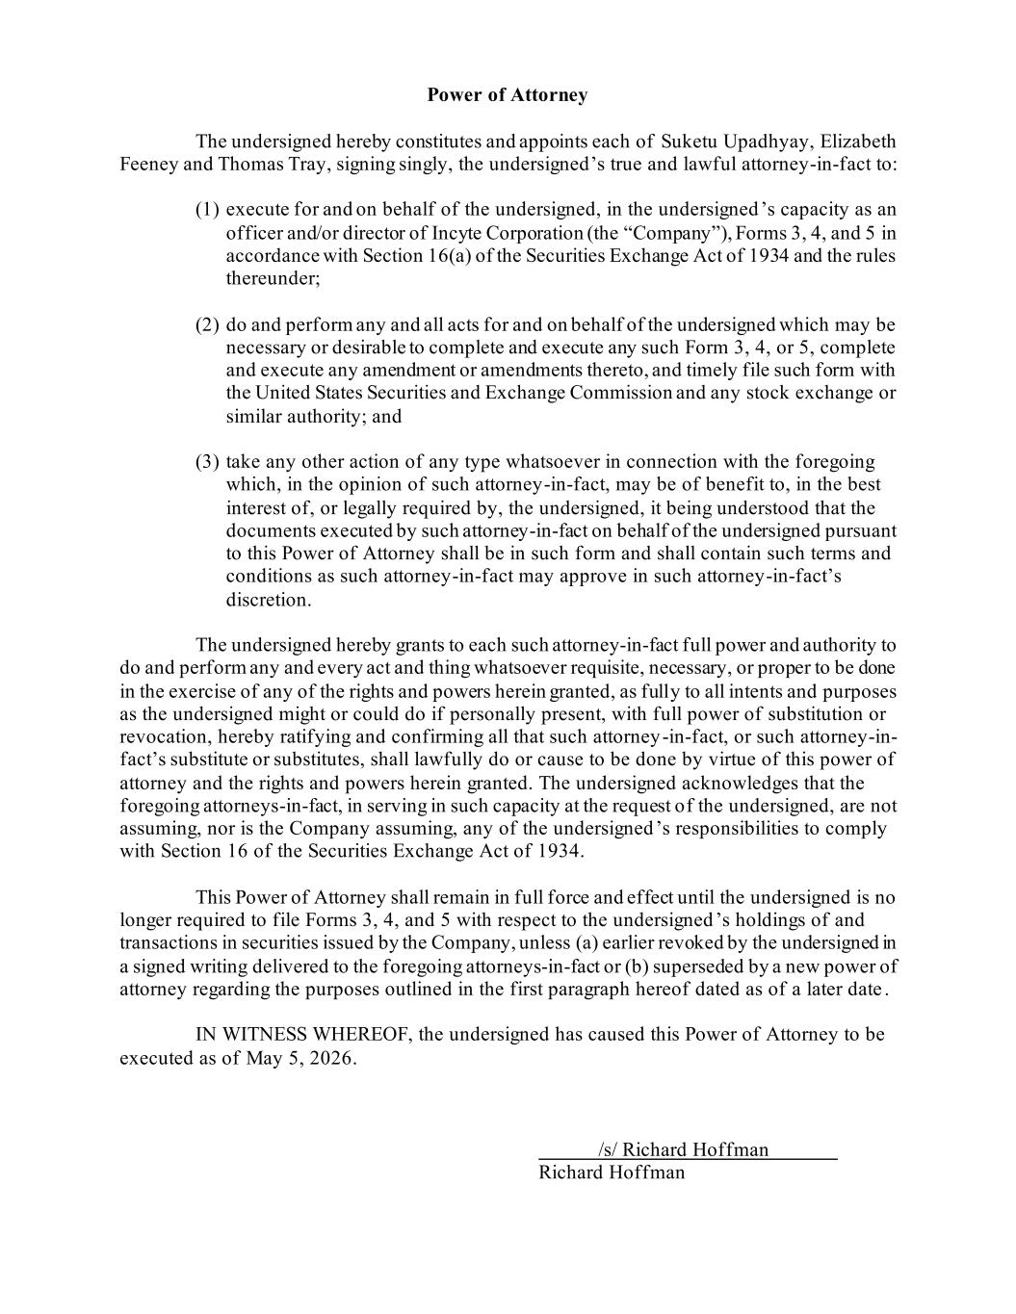
Power of Attorney The undersigned hereby constitutes and appoints each of Suketu Upadhyay, Elizabeth Feeney and Thomas Tray, signing singly, the undersigned’s true and lawful attorney-in-fact to: (1) execute for and on behalf of the undersigned, in the undersigned ’s capacity as an officer and/or director of Incyte Corporation (the “Company”), Forms 3, 4, and 5 in accordance with Section 16(a) of the Securities Exchange Act of 1934 and the rules thereunder; (2) do and perform any and all acts for and on behalf of the undersigned which may be necessary or desirable to complete and execute any such Form 3, 4, or 5, complete and execute any amendment or amendments thereto, and timely file such form with the United States Securities and Exchange Commission and any stock exchange or similar authority; and (3) take any other action of any type whatsoever in connection with the foregoing which, in the opinion of such attorney-in-fact, may be of benefit to, in the best interest of, or legally required by, the undersigned, it being understood that the documents executed by such attorney-in-fact on behalf of the undersigned pursuant to this Power of Attorney shall be in such form and shall contain such terms and conditions as such attorney-in-fact may approve in such attorney-in-fact’s discretion. The undersigned hereby grants to each such attorney-in-fact full power and authority to do and perform any and every act and thing whatsoever requisite, necessary, or proper to be done in the exercise of any of the rights and powers herein granted, as fully to all intents and purposes as the undersigned might or could do if personally present, with full power of substitution or revocation, hereby ratifying and confirming all that such attorney-in-fact, or such attorney-in- fact’s substitute or substitutes, shall lawfully do or cause to be done by virtue of this power of attorney and the rights and powers herein granted. The undersigned acknowledges that the foregoing attorneys-in-fact, in serving in such capacity at the request of the undersigned, are not assuming, nor is the Company assuming, any of the undersigned ’s responsibilities to comply with Section 16 of the Securities Exchange Act of 1934. This Power of Attorney shall remain in full force and effect until the undersigned is no longer required to file Forms 3, 4, and 5 with respect to the undersigned ’s holdings of and transactions in securities issued by the Company, unless (a) earlier revoked by the undersigned in a signed writing delivered to the foregoing attorneys-in-fact or (b) superseded by a new power of attorney regarding the purposes outlined in the first paragraph hereof dated as of a later date . IN WITNESS WHEREOF, the undersigned has caused this Power of Attorney to be executed as of May 5, 2026. /s/ Richard Hoffman Richard Hoffman

